

**MODULE:**

**Designing and Developing Object-Oriented Computer Program**

**TITLE:**

**Writing Prompts**

**March 2018**



**Important Notes:**



* Please refer to the Assignment Presentation Requirements for advice on how to set out your assignment. These can be found on the NCC Education *Campus*. Scroll down the left hand side of the screen until you reach Personal Support. Click on this, and then on Policies and Advice. You will find the Assignment Presentation Requirements under the Advice section.
* You must familiarize yourself with the NCC Education Academic Dishonesty and Plagiarism Policy and ensure that you acknowledge all the sources which you use in your work. The policy is available on *Campus*. Follow the instructions above, but click on Policies rather than Advice.
* You must complete the **‘Statement and Confirmation’**. The form is available on the Policies section of *Campus*. Scroll down the left hand side until you reach Personal Support. Click on this and then click on Policies and Advice.
* You must submit a paper copy and digital copy (on disk or similarly acceptable medium). Media containing viruses, or media which cannot be run directly, will result in a fail grade being awarded for this module.
* All electronic media will be checked for plagiarism.
* This assessment is worth **100%** of the student’s overall grade.

|  |  |  |
| --- | --- | --- |
| Student Name: | Student Number: | Centre: Daffodil International Academy |

**Marker's comments:**

**Moderator's comments:**

|  |  |  |
| --- | --- | --- |
| **Mark:** | **Moderated** | **Final** |
|  | **Mark:** | **Mark:** |







|  |  |
| --- | --- |
| ***Each time you submit an assignment you must attach this statement as the cover page for both the hard copy and the electronic version. If the statement is missing your work will not be marked.*** | |
| Student Declaration | |
| I have read and understood NCC Education’s Policy on Academic Dishonesty and Plagiarism.  I can confirm the following details: | |
| Student ID/Registration number: |  |
| Name: |  |
| Centre Name: Daffodil International Academy |  |
| Module Name: Designing and Developing Object-Oriented Computer Programs |  |
| Module Leader: **B.M Nazmul Haque** |  |
| Number of words: 1498 |  |
| I confirm that this is my own work and that I have not plagiarized any part of it. I have also noted the assessment criteria and pass mark for assignments. | |
| Due Date: 25/01/2018 |  |
| Student Signature:  Submitted Date: 29/01/2018 |  |

**Introduction:** This assignment is all about Writing Prompts. I have to make an application which will provide a series of Writing Prompts and for doing the project I will use C sharp language as object oriented program. The program will contain a main form along with some sub form. In the main form user can select a theme among the provided themes and all the properties of the theme selected by user will be shown in various groups.

**Task-1**

Using C sharp programming language I have completed the application named writing prompts. This application contains so many functions, loops, selections, classes, objects, and arrays. I tried to fill all the requirements to complete the projects smoothly.

User interface design screenshots of my application called Writing Prompts are given bellow:

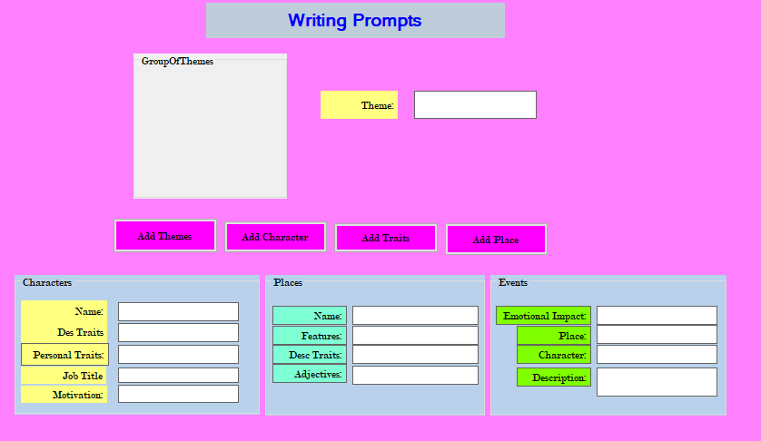

* Main screen of the application.

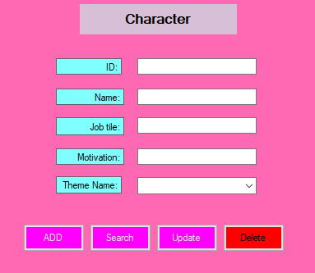

* Screen of Character Form

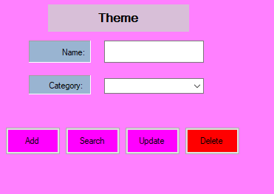

* Screen of the Theme Form.

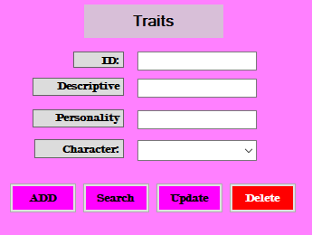

* Screen of the Form Traits.

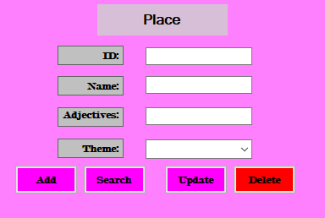

* Screen of the Form Place.

**Task-2**

For knowing the odds of an application it is must to test the application properly. I have to test my main functionalities of the application for ensuring weather they works or not. If I find any odds on the application then I have to fix them. I will have to make sure that my all coding and visual presentation works smoothly.

**Black Box testing plan:**

In black box testing I tested some visual functions to see how my graphical interface works. My black box testing plan is given bellow:

**Main Form:** When I select a theme all the properties of the theme like character, events and places is shown or not.

**Function for Main form:** When I click on the add button from main form, A new form will open on the screen and user can update, delete and search through this form.

**Sub-Form for Character:** This from will provide user to add, update, search and delete new characters.

**Form for traits:** This form is for updating, adding and deleting traits for character. User can easily change them through this form.

**White Box testing plan:**

I am going to check some functions of the themes because most of the functions are likely similar to each other. I will check functions like Add, Delete, Search and Update.

**Random Generator**: will check random generator for better performance.

**Function for Add New Character**: I will check the function for add new Character for knowing they works properly or not.

**Function for search Character**: I will check the function for search Character for knowing they works properly or not.

**Function for update Character:** I will check the function for update Character for knowing they works properly or not.

**Delete Character:** Delete Character code will be tested for ensuring the application perfection.

**Black Box Testing are given Bellow:**

1. **Main Form**

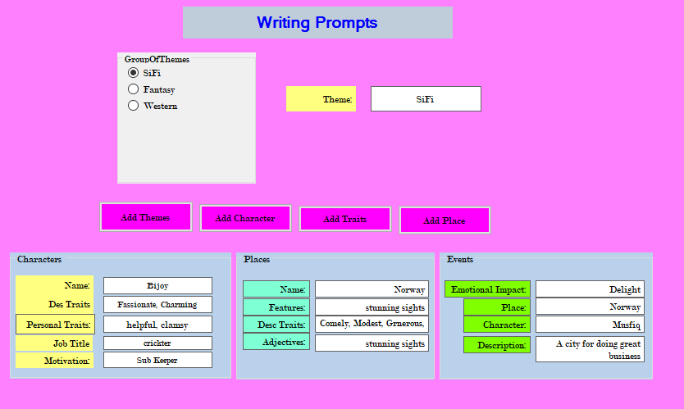

When I selected the SiFi theme all the data of the Theme are shown on the screen.

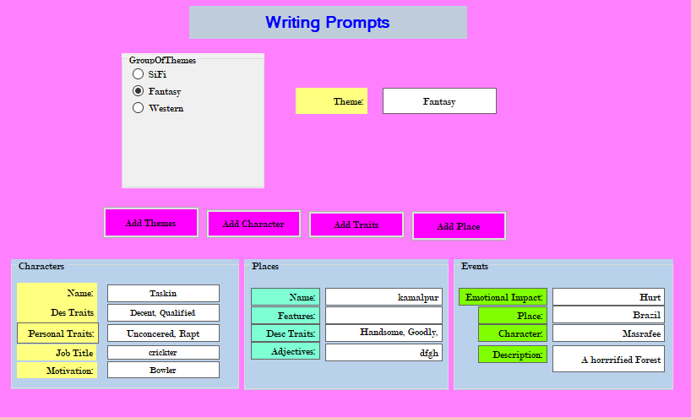

When I selected the Fantasy theme all the data of the Theme are shown on the screen.

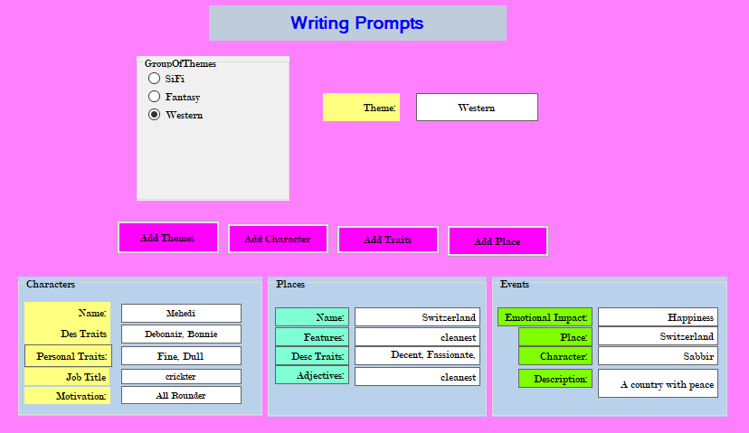

When I selected the western theme all the data of the Theme are shown on the screen.

1. **Form Theme**

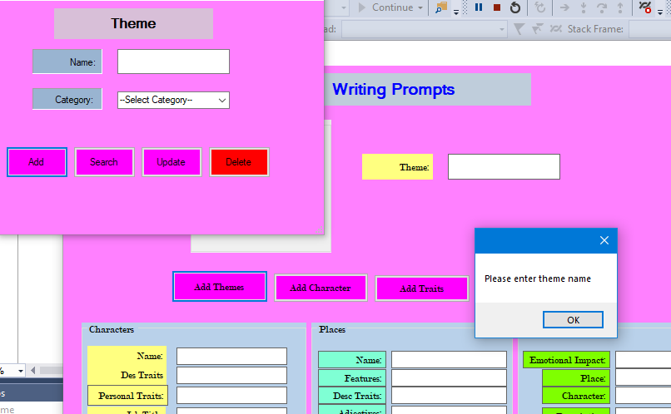

I tried to add a new theme without entering Name and Failed.

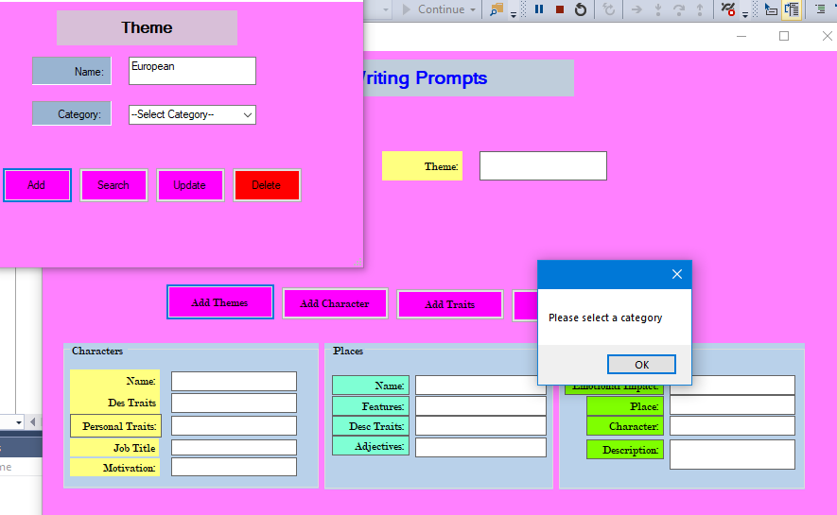

I tried to add a new theme without selecting Category and Failed.

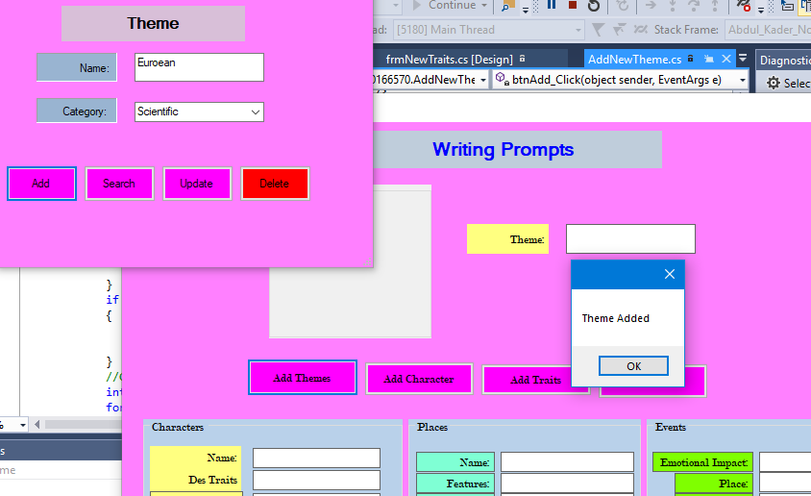

I have added a new theme successfully.

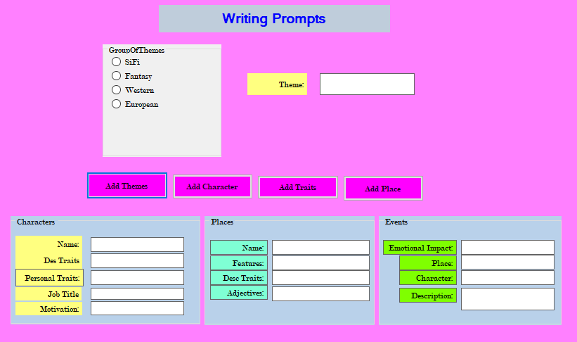

I can see on the screen that a new theme named European has been added successfully.

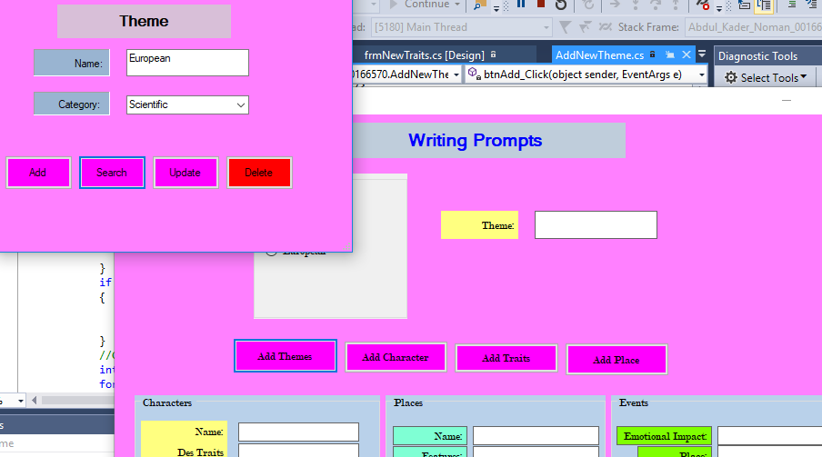

By clicking on search button I have my created theme European.

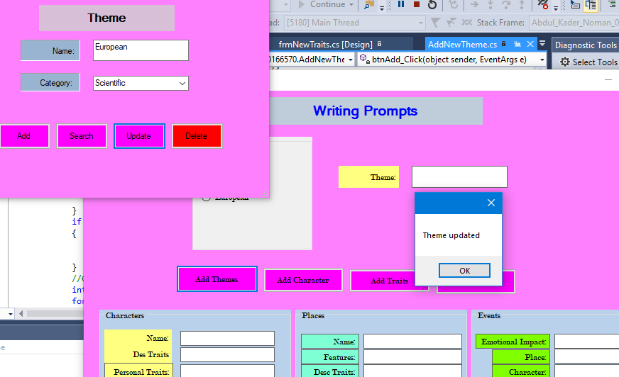

I have successfully updated my theme.

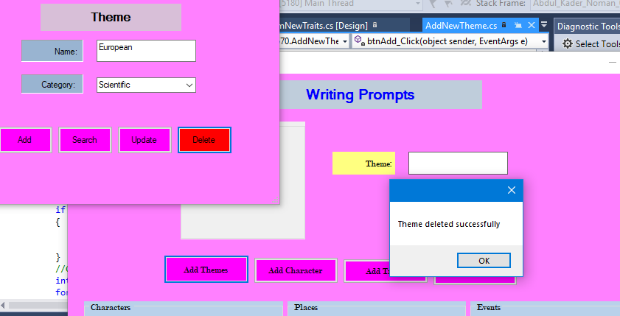

Clicking on Delete button I have successfully deleted my theme.

1. **Form Place**

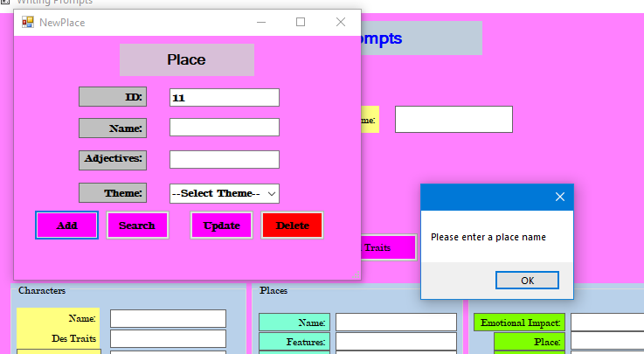

When I tried to add a new place without entering place name it sent me a message telling me to put a place name first.

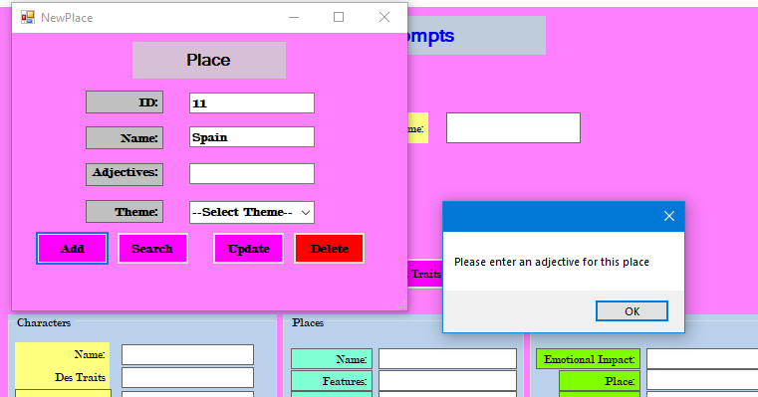

When I tried to add a new place without entering Adjective it sent me a message telling me to enter adjective for place.

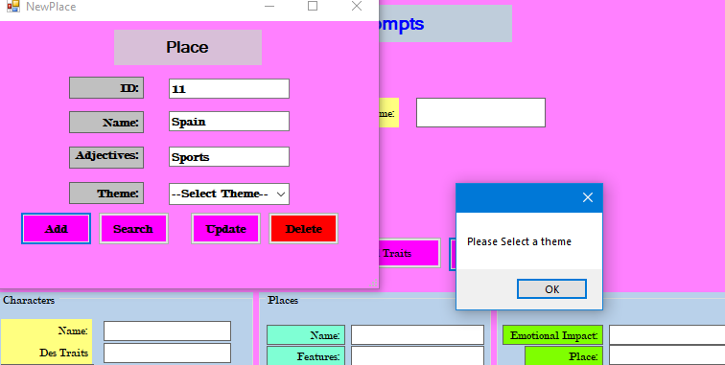

I have to select a theme for adding a place.

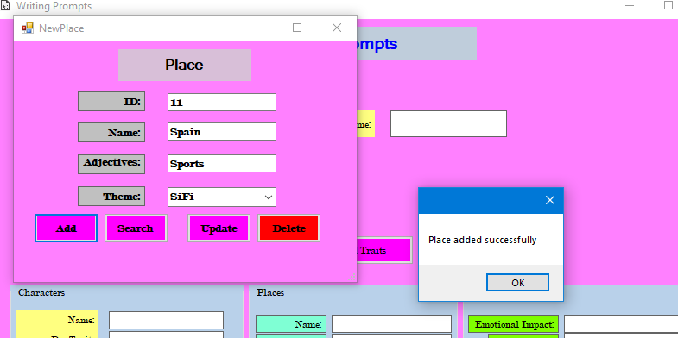

I have successfully added a new theme.

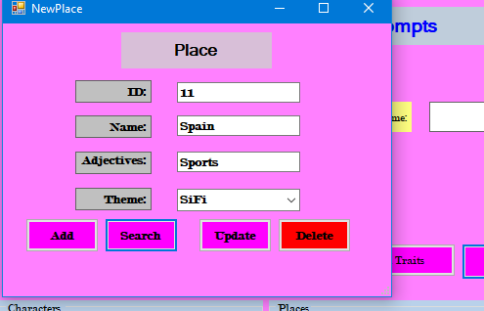

By clicking on search button I have found my newly added place.

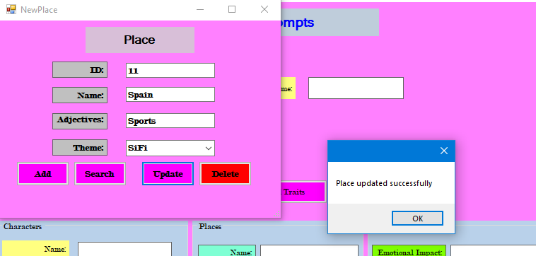

I have successfully updated a new place.

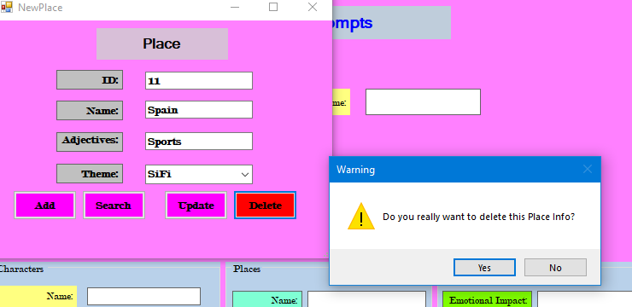

As I am trying to delete the theme it ask me that whereas I am sure or not.

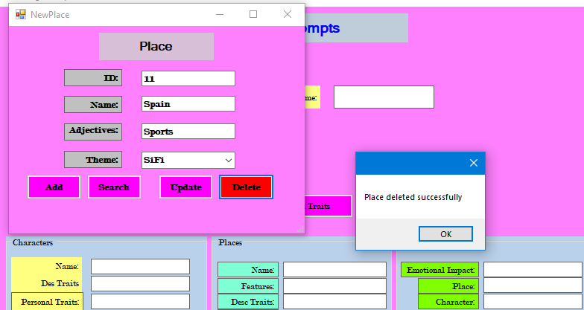

Successfully deleted the theme.

1. **From Add New Character**

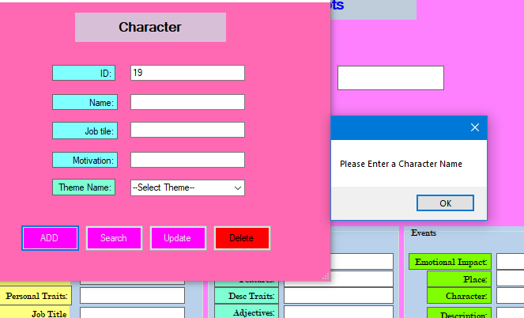

I tried to add a new Character without entering a name and failed.

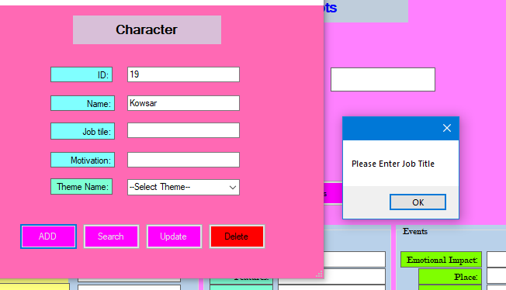

After entering character name I have to fill his job title for adding a character.

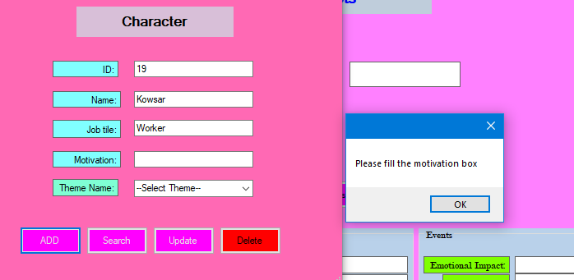

When I fill the job title then I have to give a motivation for adding a character.

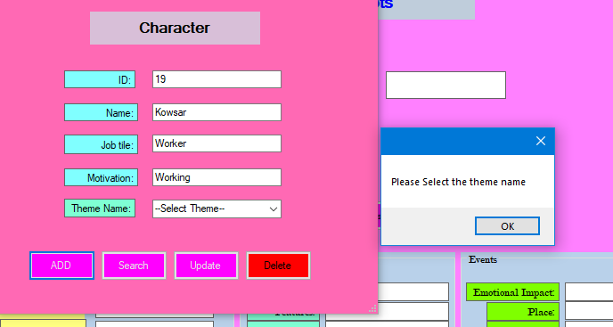

After giving all the details of a character I have to select a theme for my new character.

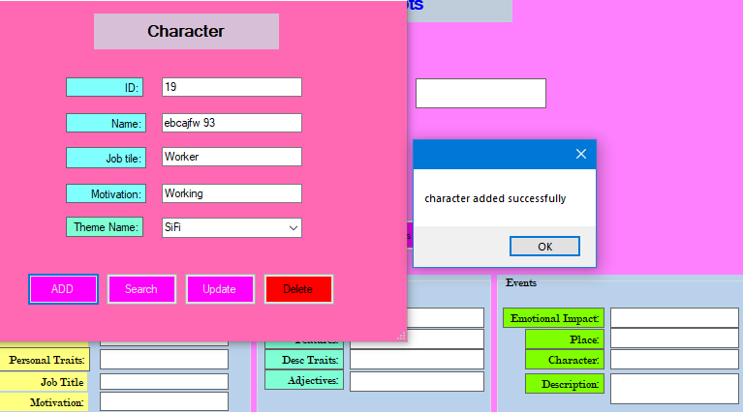

Finally I have successfully add a new character.

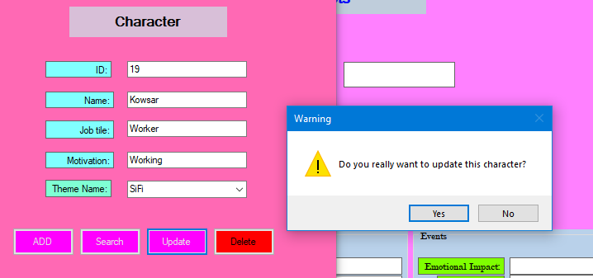

I will have to update my character for adding it correctly.

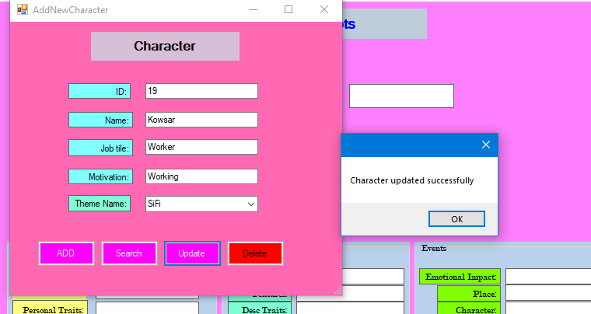

My new character has been added successfully.

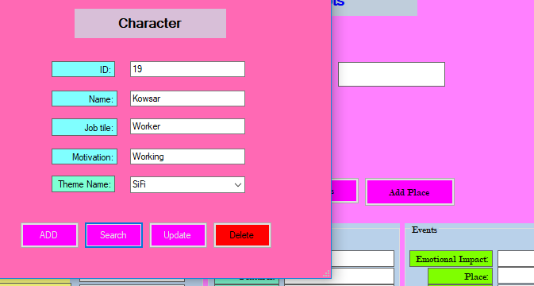

By searching it I can see that my new character has added successfully.

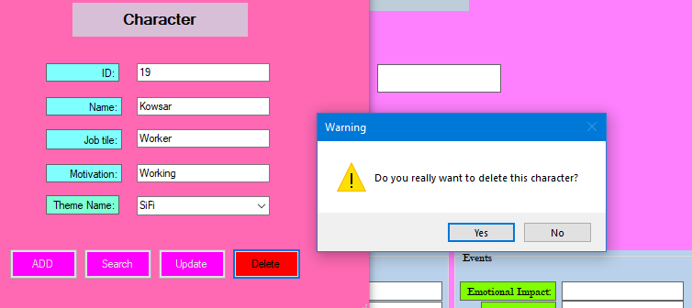

If I want to delete the character my application will ask me whereas I am sure or not.

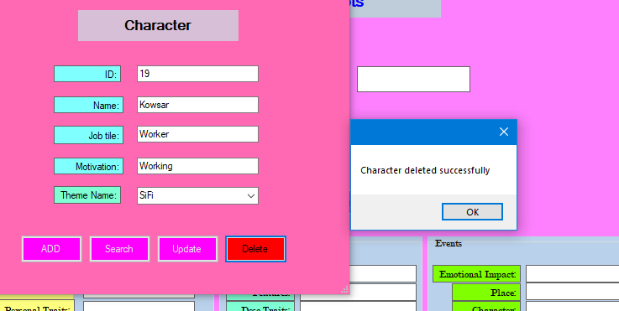

Character has been deleted successfully.

1. **Add new Traits**

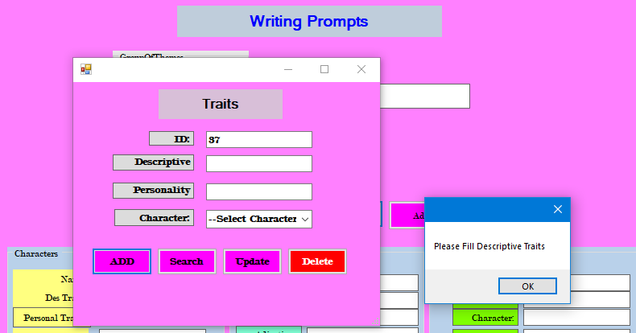

I tried to add a new Trait without entering Descriptive and failed.

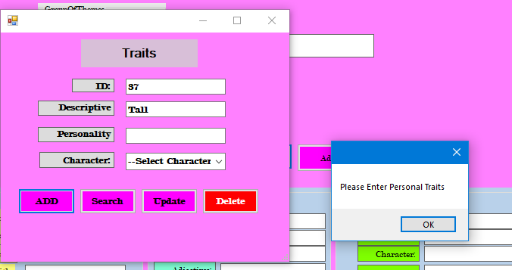

After entering descriptive I have to enter personality.

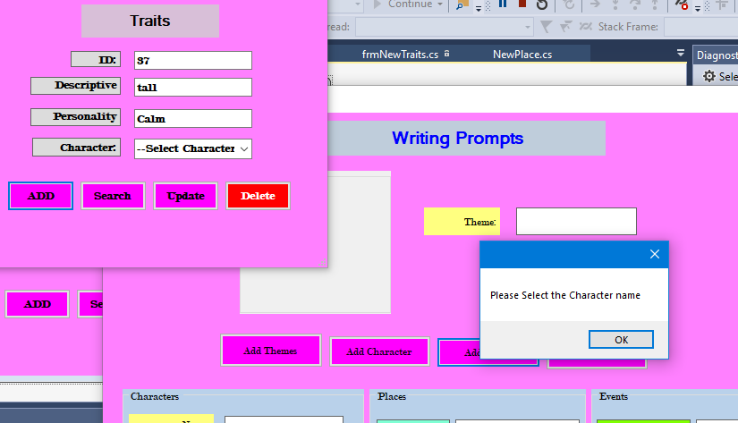

I have to select a theme for completing the process of add new theme.

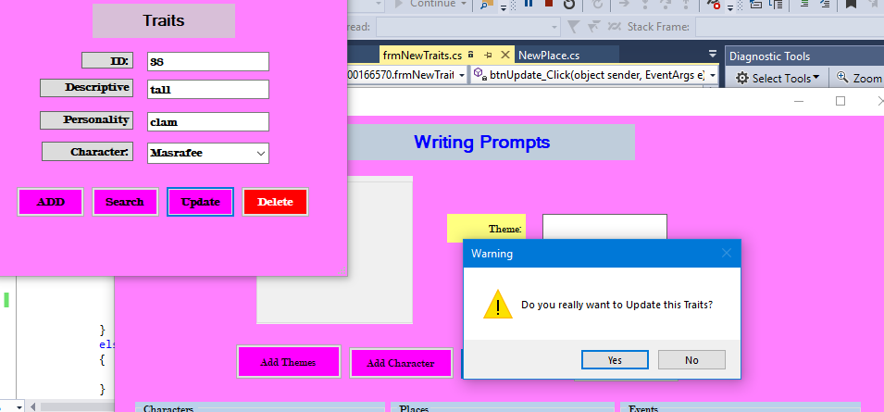

I can update traits by clicking on update button of the traits from.

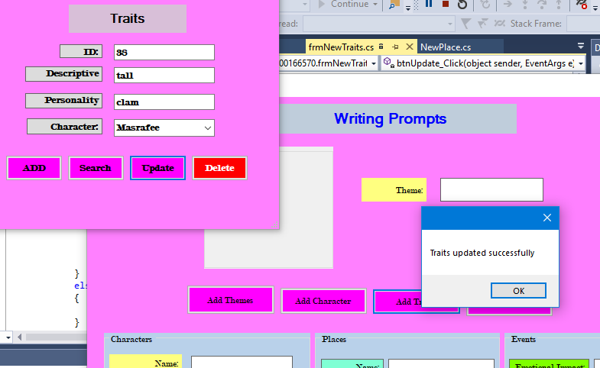

Traits has been updated successfully.

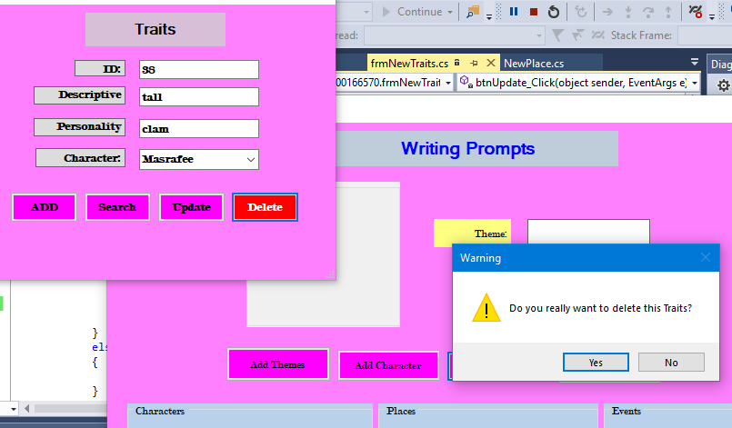

If I want to delete the trait my application will ask me whereas I am sure or not.

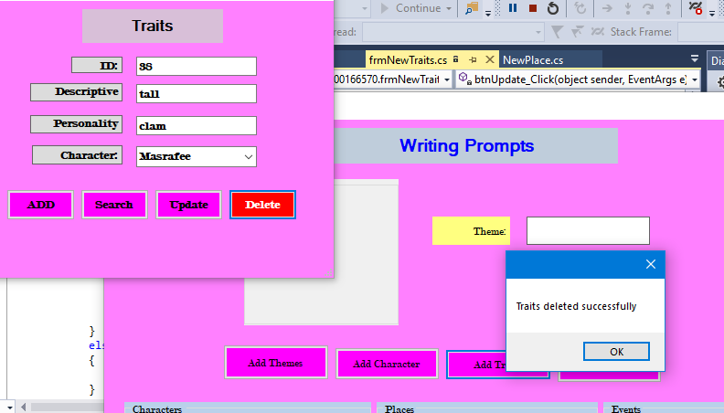

Newly made trait has been deleted successfully.

**White box testing chart is given bellow:**

|  |  |  |  |  |
| --- | --- | --- | --- | --- |
| **Test**  **No.** | **Test**  **Name** | **Screenshot of the Code** | **Expected Output** | **Actual output** |
| **1.** | **Random**  **Generator** |  | **This**  **will Generate Randomly**  **Character,**  **Traits,**  **Place**  **And**  **Events.** | **Output**  **As**  **Expe- cted** |
| **2.** | **Add new**  **Character** |  | **A new**  **Theme**  **Will**  **Be**  **Added.** | **As**  **Expec-ted** |
| **3.** | **Search**  **Character** |  | **Will**  **Show**  **The**  **Data**  **Of the**  **Searched**  **Character.** | **As**  **Excep-ted** |
| **4.** | **Update**  **Character** |  | **Character**  **Will**  **Be updated** | **Output**  **As**  **Excep-ted** |
| **5.** | **Delete**  **Character** |  | **Character**  **Will be**  **Deleted.** | **Result**  **As**  **Excep-ted** |

**Exception Handling:**

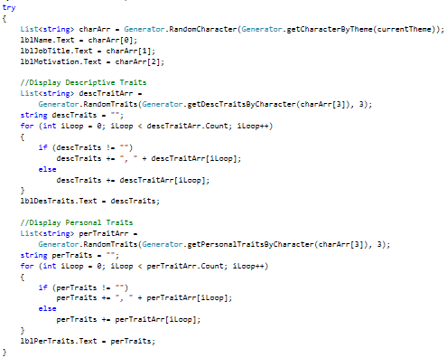

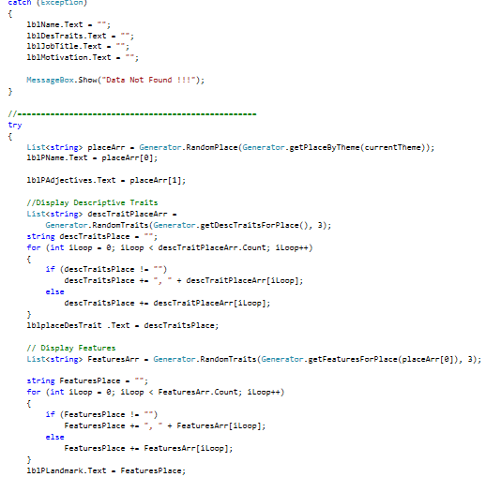

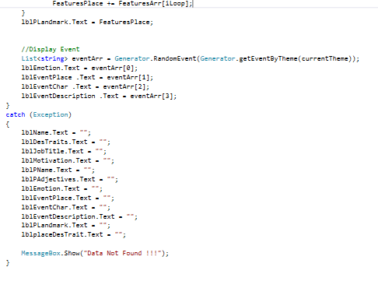

**Task-3**

**The UL Designs of my Application are given bellow:**

1. **Main Form**

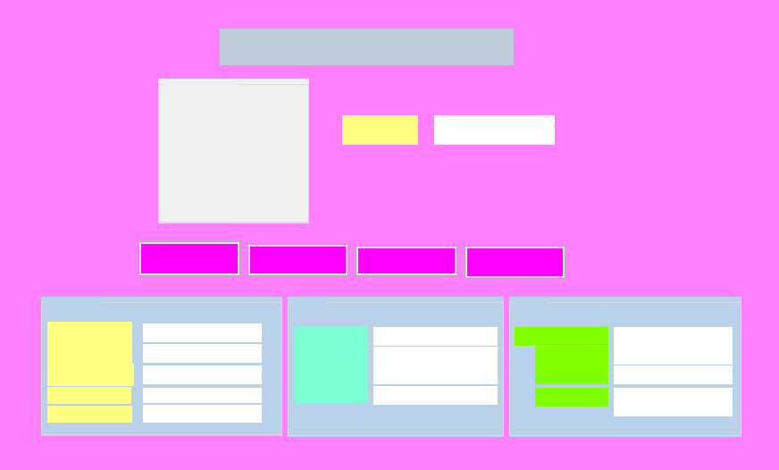

**Description:**

**Light Pink (Form):** It’s the color of my whole form background color.

**Inactive Caption (Heading):** Its refers the heading or name of my form.

**Fuchsia (Buttons):** The color of my buttons is Fuchsia.

**Aquamarine, Golden Load, Chartreuse, Control Light (Label, Combo Box):** these are the colors of my labels of the form.

**Button Face (Group Box):** The color of my group box is Button Face.

1. **Form New Place**

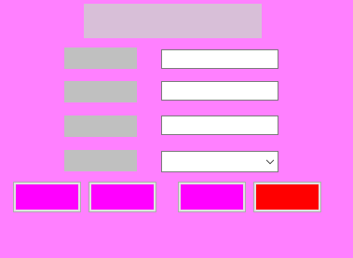

**Description:**

**Light Pink (Form):** It’s the color of my whole form background color.

**Thistle (Heading):** Its refers the heading or name of my form.

**Silver and Window (Label, Combo Box):** these are the colors of my labels of the form.

**Fuchsia and Red (Buttons):** The color of my buttons is Fuchsia.

1. **frmNewTraits**

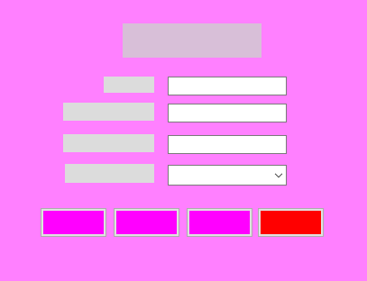

**Description:**

**Light Pink (Form):** It’s the color of my whole form background color.

**Thistle (Heading):** Its refers the heading or name of my form.

**Fuchsia and Window (Label ,Combo Box):** these are the colors of my labels of the form.

**Gainesboro** **and Red (Buttons):** The color of my buttons is Fuchsia.

1. **AddNewTheme**

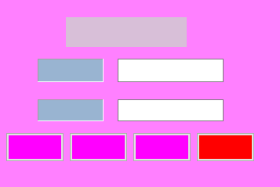

**Description:**

**Light Pink (Form):** It’s the color of my whole form background color.

**Thistle (Heading):** Its refers the heading or name of my form.

**Fuchsia and Red (Buttons):** The color of my buttons is Fuchsia.

**Active Caption and Window (Label):** these are the colors of my labels of the form.

1. **AddNewCharacter**

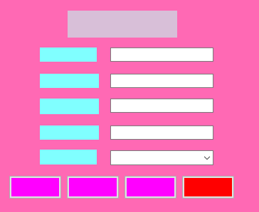

**Description:**

**Hot Pink (Form):** It’s the color of my whole form background color.

**Thistle (Heading):** Its refers the heading or name of my form.

**Fuchsia and Red (Buttons):** The color of my buttons is Fuchsia.

**Aquamarine and Window (Label, Combo Box):** these are the colors of my labels of the form.

**Class Diagram:**

Class diagram of the application is given bellow:

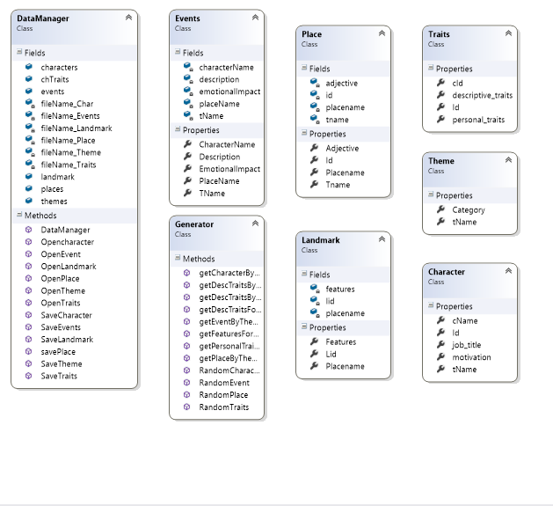

**Overview of Method and Experience:**

This application was tested by a user and user used the application smoothly and overall infrastructure was good. The application contains all the basic requirements of Writing Prompts but adding some extra function will make the application great. Above all I can say that it’s a good application but it can be great by adding some extra features.

**Recommendation for Changes:**

I have completed the project with all the requirements provided but still I can be improved a little bit by adding some extra feature on the project. On this application I can’t add new events on my application in future so, I can improve my application by adding this on my application. Beside this there is no scope for user to Land Mark in future so I can improve my application by adding this also.

**Conclusion:** I have tried my best to fulfill all the requirements of the application. I have used light colored and easy designed application for making it user friendly. I already tested the application both black and white for making the application perfect. I won’t say that it’s a great application but user will find joy and easiness using the application.